AgroMetShell Manual

Elijah Mukhala & Peter Hoefsloot
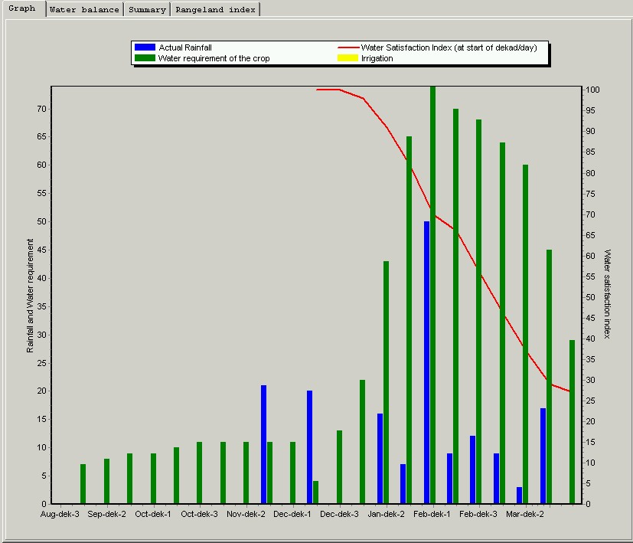



Elijah Mukhala & Peter Hoefsloot
Agrometeorology Group,
Environment and Natural Resources Service,
Food and Agricultural Organization
SDRN – Viale delle terme di Caracalla
00153 Rome, Italy

rene.gommes@fao.org

SADC Food Security Programme
Regional Remote Sensing Unit,
43 Robson Manyika Avenue
P.O. Box 4046
Harare, Zimbabwe.

rrsu@fanr-sadc.co.zw
www.sadc-fanr.org.zw

Acknowledgement

This AgroMetShell (AMS) manual has been prepared by the SADC Regional Remote Sensing Unit (RRSU), Harare, Zimbabwe. This is a joint collaboration been the Agrometeorology Group, Environment and Natural Resources Service (SDRN), Food and Agriculture organization of the United Nations and the SADC Regional Early Warning System. The manual is a step-by-step handbook for use in data preparation, running the water requirement satisfaction index (WRSI) water balance model, image creation and yield estimation once the models have been developed for crop monitoring and early warning for food security.

The first version has been under preparation since January 2004 and finalized in August 2004. It is expected that further expansion to this document will continue to include more information and exercises for practical operational agrometeorology.

The following are acknowledged for their effort in shaping the manual: Dr. Rene Gommes, Dr. Michele Bernadi, Dr. Kennedy Masamvu and all the RRSU staff.

This manual was prepared and compiled by Dr. Elijah Mukhala, SADC Regional Agrometeorologist and Mr. Peter Hoefsloot, FAO Consultant.

RRSU

August 2004

How to comment

Please feel free to comment on any of the implemented and non-implemented functions. Not much time is spent on colours, button-pictures etc. Please give suggestions. You might find bugs, although a lot of time has been spent to make the package as bug-free as possible. Please report them. Send your comments to one (or all) of the following persons:
- michele.bernardi@fao.org
- rene.gommes@fao.org
- peter@hoefsloot.com

Comments concerning the AgroMetShell manual should be forwarded to Elijah Mukhala (email: emukhala@fanr-sadc.co.zw or emukhala@yahoo.com or to the above three email addresses.
Table of Contents
Acknowledgement 1
How to comment 1
Section 1 4
Introduction 4
AgroMetShell Overview 4
Target group for AMS 6
Use of AMS in Early Warning 6
Compatibility with other software 8
WinDisp 8
Excel 8
Instat 8
AMS Products 10
Overview of products 10
Section 2 11
Getting started 11
Data requirement 11
AMS input Files 11
AMS Output Files 13
Section 3 17
AMS Weather Data Preparation 17
Importing datasets from spreadsheets and ASCII files 17
Preparing rainfall data for importing 17
Section 4 18
Importing rainfall data into AMS Database 18
Importing the crop parameter file 24
Section 5 26
Manual data entry into AMS 26
Entering dekadal rainfall data 26
Section 6 28
Calculating monthly rainfall data from dekadal rainfall 28
Section 7 29
The water balance 29
Data availability check 29
Preparing a water balance 30
Refining the water Balance 32
Filling Data gaps 32
Calculate planting dates 32
Adding Irrigation 34
Automatic irrigation 34
Running the Water balance 35
Manual irrigation 37
Removing and adding stations from the stations list 39
Section 8 40
Making images from the water balance calculation 40
Making a risk analysis for a station 41
Section 9 43
Displaying data in simple way 43
Mapping data in AMS 43
Mapping data in WinDisp 45
Section 10 47
Interpolation of data using AMS 47
Using the inverse distance interpolation method 47
Making an image using altitude as background image 49
Making an interpolated image with data for a whole season 51
From Water Balance results to yields 58
How to analyze data that have a different geographical format 58
Analyzing information on station level 58
Analyzing information on province/district level (area averaging) 59
Analyzing information on image level 59

Section 1

Introduction

Food security is one of the major challenges that developing countries experience especially Africa as a whole. The major causes of food insecurity are mainly poverty, drought, floods, civil strife and disease especially HIV/AIDS. The two areas that underpin food security deal with either challenges of food access by communities in both rural and urban areas as well as poor production as a result of deficit rainfall. Most experts in Africa dealing with food security have embraced the Household Food Economy approach which provides an understanding of the livelihoods of communities and how communities respond to shocks such as floods and drought. The Food Economy Zones provide information on which communities derive their livelihoods from agricultural production and which ones do not. There are several methods that can be and have been used to estimate yield and production depending on specific hazards. This tool can be used to provide targeted analysis based on vulnerability assessment baseline data to determine how the livelihoods of a particular zone will be impacted. In Africa, climate plays a major role in reducing crop yields and ultimately production. One of the tools that can used to provide early information as to what yields and production statistics are expected is what is being introduced in this manual. This manual has been prepared in such a way that even those who are not in the field of Agrometeorology would be able to understand the stages of data preparation and run the water balance and make use of the outputs. The manual contains several examples from different countries as it is intended to be used by many practitioners outside of Africa. Further training on AgroMetShell can requested through the SDRN FAO or the SADC Regional Remote Sensing Unit.

AgroMetShell Overview

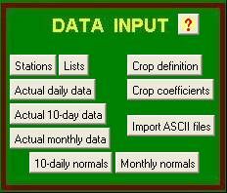
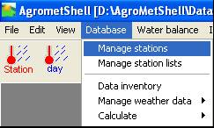
The AgroMetShell is new tool developed by FAO SDRN that provides a toolbox for agrometeorological crop monitoring and forecasting. It is a user friendly tool with a “visual menu” that offers easy access to some of the most often used functions. It also offers another choice of using a “pull down” menu. All the buttons in the visual menu have their equivalent in the main pull-down menus. For instance, the top left button on the visual menu in the DATA INPUT box can also be accessed by using the pull down menu as follows: Database ⇒ manage stations

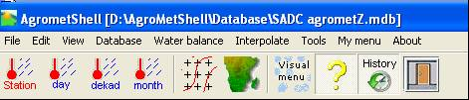
The programme includes a database that holds all the weather, climate and crop data needed to analyse the impact of weather on crops. Data can be input into the database using a variety of options, for instance, they can be:
- typed in from the keyboard,
- read from WINDISP format images or
- imported from ASCII files.
Details of how to input data will be discussed in detail in this manual to allow for first time users to be able to prepare the data and run the water balance model. A number of operations can be performed on the database, such as making backups or “flushing the database”. Many options under Database ⇒ configure should be used with the utmost care and only by experienced user, and after running the back-up option Database ⇒ configure ⇒ Back up current database.

Within the AgroMetShell, the FAO Crop Specific Soil Water Balance can be operated in two modes, (1) “monitoring mode” or (2) in “risk analysis” mode. The monitoring mode is an analysis of one growing season covering many stations in a specific area, usually a country or a province in a country. This would be performed from the beginning of the growing season until the harvest time. However, early warning information would have to be extracted before the harvest time. The second mode (risk analysis) covers the same type of analysis, but for one station only, and over many years. This provides the food security expert with some information indicating whether a particular crop should actually be grown in that particular area or not, looking at the output of a risk analysis which show how many years or seasons the water requirement was satisfied or have been beyond a certain threshold value.

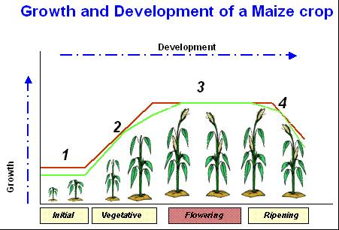
The FAO Crop Specific Soil Water Balance model produces a number of outputs for the various stages in the growth and development of the crop as shown the figure. In developing models for yield estimation, the various outputs are regressed with historical yield data. The water balance variables that are produced include, such as excess soil water, actual evapotranspiration, soil water deficit over the initial, vegetative, flowering and ripening phase. Other outputs include total water requirement as well as water requirement satisfaction index at the time of monitoring as well as at the end of the growing season. These outputs can be mapped separately for crop monitoring as will be discussed in detail in this manual.

For crop forecasting, the water balance variables are normally averaged over administrative areas and then compared with crop yields through multiple regression to derive yield functions that in turn can be used to estimate yields.

In addition to the FAO Crop Specific Soil Water Balance, the programme proposes many other useful tools, for instance the calculation of rainfall probabilities, spatial interpolation tools and the determination of growing season characteristics based on climatological parameters.

Target group for AMS

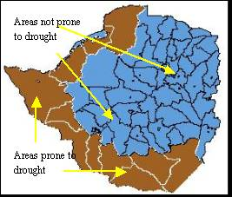
Advance knowledge of the potential agricultural production is important for those in decision-making positions and those whose job description is to provide this information. In early warning, advance warning is critical and this requires appropriate information for decision making. In the SADC Region Livelihood-Based Vulnerability Approaches have largely been adopted and incorporated into the Vulnerability Activities Committee activities. These approaches try to understand -
- How people survive in most years (food, income and expenditure) and
- How households cope when ‘hazards’ occur etc.
Food security experts using the food economy approach in assessing the vulnerability of communities especially when it come to looking at the impacts of shocks such us floods and drought can make use of the AgroMetShell. Once zones prone to drought or floods have been identified (figure ), the AgroMetShell water balance can be used to estimate yields and production as well as areas experiencing excess moisture for appropriate interventions for disaster management. The AgroMetShell is a simple to use tool targeted at a wider user community which includes: Agronomists, Agrometeorologists, hydrologists, decision makers, Food Security Economists, Food security experts, climatologists, humanitarian aid specialists, disaster management specialists and many other professions with an interest in food security and disaster management.
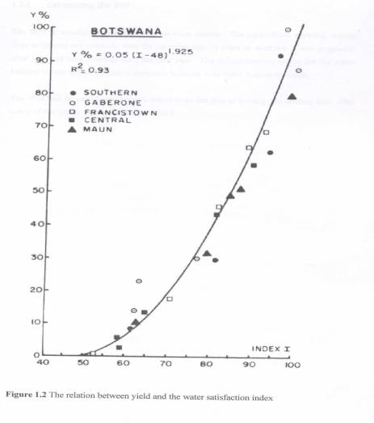

Use of AMS in Early Warning

AMS is a tool that was developed specifically for early warning purposes. Humanitarian assistance requires that grain deficits are computed long before the harvest takes place. This allows Governments and the international community enough time to mobilize resources for relief purposes. The development of AMS started in the 1980’s to try and find a tool that would help with yield estimation for early warning purposes and it was then that the water requirement index (WRSI) was used to relate to yield to moisture condition and a relationship was established (see graph). However, the effect of water deficits on crop yields has been actually established long before. At that time, the tool was referred to as FAOINDEX. It is this tool that has now been developed further into what is now known as the AgroMetShell. At that time, the major predictor of yield was WRSI but with the new development of AMS, there are several outputs/parameters from the water balance model that can be regressed with historical yield to develop models that may be used for yield estimation and production once the area under cultivation has been established.

For early warning purposes, the tool is used to monitor the growing season from the onset of the planting. The various outputs indicate which areas in a region, country or province have received minimal rainfall, water deficits, excess water at the various stages of crop growth as these affect yield ultimately. As input data is on a dekadal basis, such information can also be obtained at the same intervals and when persistent water deficits or indeed excess water are experienced, this may lead to poor crop yields, resulting in poor production and food insecurity.

Compatibility with other software

The developers of the AMS software recognize that the more versatile the software is, the more food security experts or practitioners will use it. Therefore, AMS was developed with this view for maximum utility with commonly used software. AMS is a freeware that was paid for by the United Nations Food and Agriculture organization for the sole purposes of early warning for food security to save human life. AMS is compatible with the following software:

WinDisp

AMS is compatible with WinDisp. WinDisp is another software developed by FAO for analysis and viewing remote sensing data for seasonal monitoring for early warning for food security. Windisp is a public domain, easy to use software package for the display and analysis of satellite images, maps and associated databases, with an emphasis on early warning for food security. WinDisp was originally developed for the FAO Global Information and Early Warning System. It allows users to:
- Display and analyse satellite images
- Compare two images and analyse trends in a time-series of images
- Extract and graph trends from a number of satellite images such as during the growing season for comparison with other years
- Compute new images from a series of images
- Display tabular data in map format
- Build custom products combining images, maps and specialised legends
- Write and execute batch files to automate routine and tedious tasks
- Build a customized project interface for providing users with detailed menus of available data for a country or a specific area
Images produced by AMS can be viewed using WinDisp as well as further analysis for better presentation food security bulletins.

Excel

AMS is also compatible with Excel. Excel is one of the most commonly used spreadsheets. Excel is used to prepared input data for importation into AMS. In many cases, data may actually be archived in an excel format such that importing such data is easy. The process of importing data from Excel is very easy as will be explained in the manual.

Instat

There have been discussions to make the two software compatible as Instat is very strong in climate data analysis, an important component in crop monitoring and food security. Instat+ is a general statistical package. It is simple enough to be useful in teaching statistical ideas, yet has the power to assist research in any discipline that requires the analysis of data. Instat has been used widely in the UK and elsewhere by a range of companies, research institutes, schools, colleges, universities and private individuals.

At The University of Reading it has been used extensively on training courses run by the SSC and the School of Applied Statistics. It has also been used in many countries on statistics courses and on courses related to health, agriculture and climatology. "Instat+" (i.e. the Windows version of Instat) has been developed mainly because of its continued use for the analysis of climatic data. Funding from the UK Met Office for a new climatic version, supplemented by support from the SSC and the efforts of other friendly collaborators, led to the Windows version, which was first used on training courses in 1999.

AMS Products

Overview of products

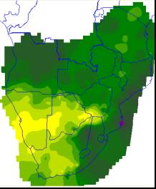  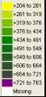  AMS will provide images of total water requirement during the growing season. This provides information of water demands of the crop in different areas of the country.  Total Water Requirement | 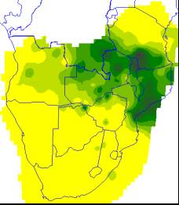  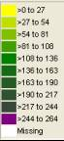  AMS will provide the images of the excess water during the flowering stages of the crop. This information will provide information as to what caused crop failure as crops are sensitive to excess water at this stage.  Water Excess (Flowering)
AMS will provide the images of the water deficits during the flowering stages of the crop. This information will provide information as to what caused crop failure as crops are sensitive to water deficits at this stage.  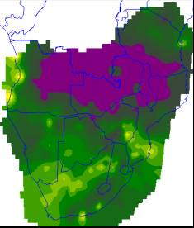  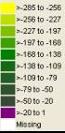  Water deficits (Flowering) | 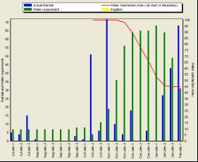  AMS will provide a graph that shows the performance of the rainy season in terms of satisfying the water requirement of the crop. Each time the crop experiences a water deficit, the index drops and when the index drops to below 50%, there is total crop failure in that district.

Section 2

Getting started

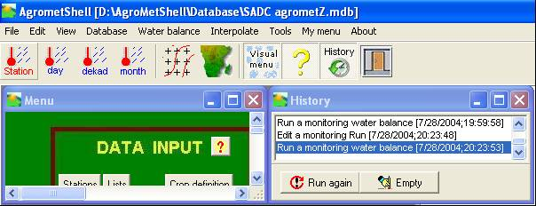
To use the AgroMetShell effectively, it is important that all the necessary data requirements are in place. Data can be input into the database using a variety of options, for instance, they can be typed in from the keyboard, read from WINDISP format images or imported from ASCII files. AgroMetShell is a new development from the old FAOINDEX that was used in agricultural season monitoring. Therefore, there is a lot of data that was prepared for the old software. To make use of this data set, this manual will illustrate importing of data into the AgroMetShell database to run the water balance model. If data has to imported, it is advisable that the data is prepared in Excel and then saved as comma separated values (CSV). It is important to familiarise oneself with the main menu of the AgroMetShell which is shown in figure.

Data requirement

AMS input Files

To run any model or computer programme, data availability forms an important component of the whole process. The data requirement of AMS are quite reasonable when you compare it to other heavy duty models for crop simulation. There are basically 10 input files that one needs, to be able to run a water balance model in AgroMetShell as shown below. However, it may not be necessary to have all the input files listed depending on the circumstances. These circumstances may be that you are unable to calculate evapotranspiration on a dekadal basis and hence preparing an evaporation file may be difficult and one has no option but to use the normal evapotranspiration file. However, should the data be available, AMS has extra tools among which the tool to calculate evapotranspiration is one of them. There are also instances where the monitoring is done for rain-fed crops and therefore it may not be necessary to have a file on irrigation.

This basically reduces the number of files to run the water balance to 5 input files. Every time the user requests a water balance calculation to be carried out, the programme prepares a set of files that will be read by the Crop Specific Soil Water Balance programme to compute the water balance variables (such as soil moisture, actual evapotranspiration over the vegetative phase or the water stress at flowering, etc).

The files required are in comma-separated quoted string format and can be directly imported into a spreadsheet. All the files will have common data in the first four columns which will contain:

- "NAME", the station Name
- "LON", the longitude in decimal degrees
- "LAT", the latitude in decimal degrees
- "ALT", elevation above sea level

To run a crop specific water balance calculation, one needs the following files:

Input 1: Country Name_2003_Crop_Dekad_Input.dat

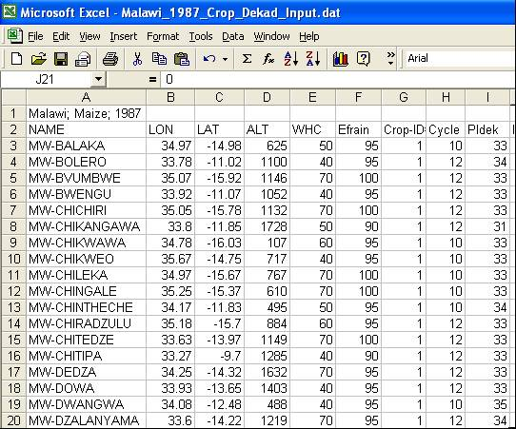
The file contains a summary of the parameters used to run the water balance, including the following:

- "WHC", soil water holding capacity
- "Efrain", effective rain (a percentage by which actual rain is multiplied to assess actual water supply. Usually Efrain<100% on slopes and Efrain>100% in low lying areas
- "Crop-ID#", the internal identification number of the crop
- "Cycle", the cycle length in dekads
- "Pldek", the planting dekad, a value between 1 and 36
- "Irrig", the type of irrigation (1=yes, 0=no and 2=automatic)
- "BundH", the height of the bund, for irrigated crops
- "k1","k2","k3","k4"…. Up to the value corresponding to the last dekad of the cycle, crop coefficients KCP

Input 2 and 3: Country Name_2003_Rain_Dekad_Input.dat
Country Name_2004_Rain_Dekad_Input.dat

The two files have actual rainfall for two consecutive years, as it often occurs that the crop is planted in one year and harvested in the following one. This kind of situation is what happens in southern Africa where rainfall commences in September/October of one year and terminates in April/May of the following year. However, in situations where an agricultural season falls within a calendar year, AMS will still work.

Input 4 and 5: Country Name_2003_Irrigation_Dekad_Input.dat
Country Name_2004_Irrigation_Dekad_Input.dat

The files contain actual values only if they have actually been provided. In monitoring rain-fed crops, this may not be necessary.

Input 6 and 7: Country Name_2003_PET_Dekad_Input.dat
Country Name_2004_PET_Dekad_Input.dat

The two files have actual potential evapotranspiration for two consecutive years, as it often occurs that the crop is planted in one year and harvested in the following one. Evapotranspiration plays an important role in the water balance as it represents the atmospheric demand.

Input 8 to 10: Country Name _Normal_Rain_Dekad_Input.dat
Country Name _Normal_PET_Dekad_Input.dat
Country Name _Normal_Irrigation_Dekad_Input.dat

The files contain normal rainfall, PET and Irrigation. The data from these files is utilized if the actual data is missing in the input files.

AMS Output Files

The programme generates 18 output files. It is not necessary that the user knows the details of the structure of those files, but with experience you may feel the need to carry out some non-standard analyses, in which case the information below will be of help. The names of output files are assigned automatically to the files based on the year, file list, type of data (input or output, daily or by dekad, actual or normal data) so that the file contents should be easy to determine. In addition, the first line of each file has a description of the data. Missing values in the files are usually coded as –999. All input and output files with DAT extensions follow the same “FAO format”.

Two types of output files are produced. Those with extension TXT (text) provide some descriptive material about the crop monitoring exercise, while those with DAT extensions are in comma-separated quoted string data files used by other options of the programme, for instance many of the options under the Tools menu.

Output 1 and 2: TXT (text) output files, Country Name _2004_Details_Dekad_Output.txt and Output_Comments.txt

Output_Comments.txt simply lists information about the files as they are processed. An example follows:

AO-SUNGINGE : No calculations done: Missing Planting Dekad
BW-BAINESDRIFT : No calculations done: Missing Water Holding Capacity
BW-BOBONONG : Water balance calculated successfully
MW-MAKHANGA : No calculations done: Missing Planting Dekad
MW-MAKOKA : Water balance calculated successfully

The second file (Country Name_2004_Details_Dekad_Output.txt) contains the full details about the water balance. An example is given below. The abbreviations have the following meaning: NOR is normal rainfall, ACT is actual rainfall, WRK stands for “working” rainfall, i.e. WRK=ACT*EfRain/100 if Act is available, otherwise WRK=NOR*EfRain/100, Irr is the irrigation amount if any, PET is the potential evapotranspiration while WR (the water requirement) is the product of KCR*PET. AvW is the crop available water, S/D stands for water Surplus or Deficit and, finally INDEX is the Water satisfaction index, the percentage of the crop water requirements that has actually been met. The end of the table lists actual evapotranspiration, water surplus and deficit by phenological phases:

Station number: 29/ Crop 1
Country Name: BW-MARTINSDRIFT (Elevation:820 m)
Crop type: Maize
Cycle length: 12 dekads (C)
Total water requirements: 561 mm (TWR)
Normal water requirements: 561 mm (TWRNor)
Planting dekad: 34 (P)
Maximum soil water storage: 100 mm (H or WHC)
Effective/Total rain: 100 % (E or EfR%)
Irrigation applied: No
Pre-season Kcr : 0.19

The actual rangeland index uses only actual data (NO estimates)
DATE NOR ACT WRK IRR PET KCR WR AvW SW S/D INDEX
Aug-dek-3 0 0 0 0 41 0.19 8 -8 0
Sep-dek-1 2 0 0 0 45 0.19 9 -9 0
Sep-dek-2 3 0 0 0 49 0.19 9 -9 0
Sep-dek-3 5 0 0 0 52 0.19 10 -10 0
Oct-dek-1 3 0 0 0 56 0.19 11 -11 0
Oct-dek-2 11 4 4 0 59 0.19 11 -7 0
Oct-dek-3 18 0 0 0 59 0.19 11 -11 0
Nov-dek-1 21 0 0 0 60 0.19 11 -11 0
Nov-dek-2 21 13 13 0 60 0.19 11 2 2
Nov-dek-3 23 0 0 0 62 0.19 12 -12 0
Dec-dek-1 17 40 40 0 63 0.07 4 36 36 0 100
Dec-dek-2 17 0 0 0 63 0.22 14 -14 22 0 100
Dec-dek-3 20 27 27 0 64 0.37 24 3 25 0 100
Jan-dek-1 26 29 29 0 63 0.71 45 -16 9 0 100
Jan-dek-2 27 7 7 0 62 1.10 68 -61 0 -52 91
Jan-dek-3 28 43 43 0 59 1.25 74 -31 0 -31 85
Feb-dek-1 18 9 9 0 56 1.25 70 -61 0 -61 74
Feb-dek-2 16 17 17 0 52 1.25 65 -48 0 -48 66
Feb-dek-3 13 10 10 0 51 1.25 64 -54 0 -54 56
Mar-dek-1 15 5 5 0 51 1.19 61 -56 0 -56 46
Mar-dek-2 14 19 19 0 50 0.90 45 -26 0 -26 41
Mar-dek-3 14 32 32 0 46 0.60 28 4 4 0 41

Phase ETAt Surplus Deficit
Initial 18 0 0
Vegetative 85 0 -52
Flowering 84 0 -250
Ripening 47 0 -26

Surplus: 0mm (WEXt) Deficit: 328mm (WDEFt)
ETAt: 234mm % data avail: 100% (%AVAIL)
Norm.index: 40% (INDXn)

Output 3 to 6: DAT output files,
Country Name _1991_WaterSatisfactionIndex_Dekad_Output.dat,
Country Name _1991_WaterStorage_Dekad_Output.dat,
Country Name _1991_WaterSurplusDeficit_Dekad_Output.dat and
Country Name _1991_ActualPET_Dekad_Output.dat

The files are "monitoring-oriented" as they contain sequences of several dekad values for display and inter-station comparisons. They respectively contain water satisfaction index values, soil moisture, water surplus or deficit and actual evapotranspiration, dekad by dekad, for all the stations in the list. Note that dekads are crop dekads (from 1 to cycle length). Values beyond cycle length are coded with the default value for missing data. D1, D2...D36 are the dekad numbers in crop dekads (i.e. planting dekad is 1 and the last values corresponds to C, the cycle length).

Output 7: Country Name _1991_RangelandIndex_Dekad_Output.dat

The "rangeland-index" (RI) is the classic FAO water satisfaction index computed for periods of 5 dekads, with normal evapotranspiration kept at potential level (KCR=1) and an assumed WHC of 50 mm. Similar to moving averages, the value assigned to a dekad corresponds to the five-dekad period centred about that dekad. Thus 3 for dekads 1 to 5, 4 for dekads 2 to 6... The rangeland index, when plotted over time, assumes a smoothed aspect, as shown in the figure below that compares "rangeland index" (RI) with rainfall (mm) in Msabaha (Kenya) in 1984. RI is associated with crop phenology. Based on local experience, there is usually a rather good association between planting and the RI. For instance, in Tanzania, it was found that the planting of millet usually occurs when the rising RI curve crosses the 0.4 (40%) threshold.

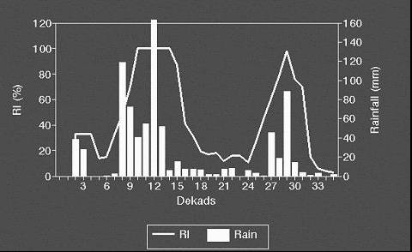

The RI is computed using actual rain (not "working rain" as described above, i.e. future values are coded as missing and not taken as their normal).

The dekads when the RI curve passes the 30 to 70% thresholds is given in the second text output file (Country Name _1991_Details_Dekad_Output.txt above).

Output 8: Country Name _1991_Summary_Dekad_Output.dat

The "summary" output file is certainly the most useful, as it lists the parameters which are likely to be used for further processing and analysis, in particular for developing yield models for yield estimation and crop forecasting. In addition to station ID, longitude (X) and latitude (Y), %AVAIL (percent of actual data used in the calculations) and Z (elevation) the variables listed in the "summary" are the following:
H and WHCi, the soil Water Holding Capacity, and its initial value, respectively;
EfR%, the ratio between effective and actual total and rain, in percent (Efrain, see above);
P, the planting dekad (1-36);
C, the length of the crop cycle (dekads);
TWR, total water requirements in mm;

Indx, IndxNor and IndxLatest, FAO soil water satisfaction index, in % of requirements, respectively actual, normal and "last" values. "Actual" corresponds to the value expected at the end of the cycle, "normal" is the end-of-cycle index computed with normal rain and PET, all other parameters being those from the crop file; the "last" value is that of the last dekad for which actual data are available ([1]);

WEXi, WEXv, WEXf, WEXr, WEXt, water excess over the phenological phases described as initial, vegetative, flowering, harvest and the whole cycle (sum of previous values)

WDEFi, WDEFv, WDEFf, WDEFr, WDEFt, water deficit over the phenological phases and the value totalled over the growing cycle

ETAi, ETAv, ETAf, ETAr, ETAt, actual evapotranspiration over the phenological phases and the value totalled over the growing cycle

ETA: actual crop evapotranspiration (i.e. actual crop water consumption), a factor directly related with crop yield;

%Av, ("available") the percentage of actual rainfall data used for the calculations (the rest being assumed to be "normal")

Cr1a to Cr4a and Cr1n to Cr4n (for "Crossing" and "Normal Crossing") indicate the dates (dekads) when the rangeland index (see above) crosses the 0.4*PET line. The dekads given in the file can be used to map the beginning of the actual (current) season (Cr1 to Cr4) and the normal beginning (NCr1 to NCr4). In areas with only one rainfall peak, there is only one "normal" start, but there are two in bimodal rainfall areas. In marginal areas, where rainfall is very close to 40% of PET, there may be more than one "start" even in areas with uni-modal rainfall. The actual starts may be more than the "normal starts", particularly in the not so rare event of "false starts" when rain decreases again after a first start: in the field, farmers must frequently replant when this happens.

Section 3

AMS Weather Data Preparation

Importing datasets from spreadsheets and ASCII files

To run a water balance model in AMS, appropriate data preparation is an important component of the entire process. This can be done by typing in the information from the source document into the AMS database. However, this is subject to error and takes a long time to complete. Therefore, the best way to input data is to import it.

AMS can import all ASCII data as long as the data are organized in columns and rows. Data can only be imported into AMS if the file to import contains a column that can be matched with a corresponding AMS station list. Linkage can be provided through the station code or through the station name. Its always easier to import data from an excel file that has been served as “comma separated values” (*.csv). As indicated earlier on, to run the water balance, one needs at least five files, it is advisable to prepare a template in excel with the station names and their longitude, latitude and altitude. The template is then used to prepare all the required files to run the water balance.

Preparing rainfall data for importing

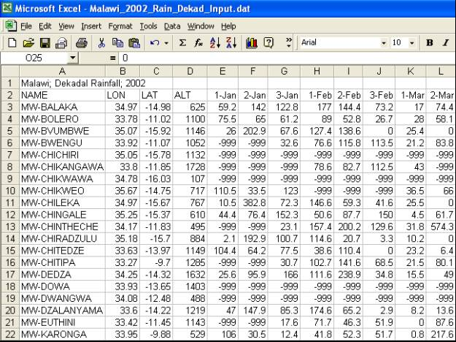
In excel, prepare rainfall data for importing in columns with station name, longitude, latitude and altitude. The following columns should contain dekadal rainfall data from January to December arranged in dekads from 1-36 as shown in figure. The agricultural season in southern Africa overlaps two calendar years and therefore, rainfall data for two calendar years should be prepared as shown in the figure. Please make sure that the file names indicate appropriately the data contents e.g. 2002_Rain_Dekad_input.dat will contain dekadal data for the year 2002 while
2003_Rain_Dekad_input.dat will contain dekadal data for the year 2003. Once preparation of data is complete in excel, save the data as “comma separated values” as follows:

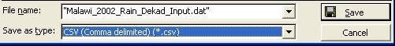

Once the data has been prepared, it is now ready for importing into the AMS database.

Section 4

Importing rainfall data into AMS Database

Before importing data into the AMS, it is important that you create a list to which all the data you import will go to. This is done by activating Database ⇒ Manage station lists
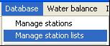
Then the following screen appears which requires that you specify a new name for the list. After this you are ready to import data.

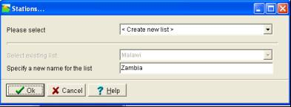

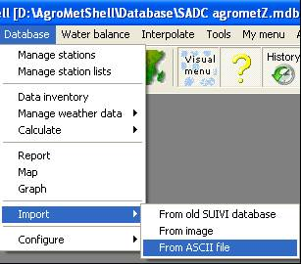

To import data into the AMS database, you can use the “visual or pull down menu. When using the pull down menu, activate Database ⇒ Import ⇒ From ASCII file as shown in figure.

The following screen appears as shown in figure with a statement “import values from text file into database”. Specify the name of the file that you intend to import in the blank space as shown. Then click
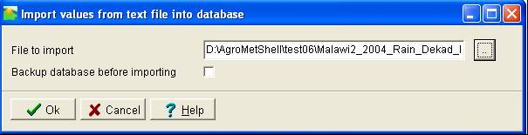

Once you click , the following screen as in figure comes up. With this screen, you help AMS by indicating the format by which the data is separated. The data is separated by comma. This may be either by space, semicolon or tab. The data-lines begin at line 3 and the text qualifier is “ and missing value code –999 or -99. These have to be indicated for the data to be imported correctly. Then click

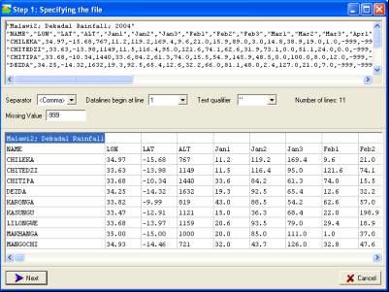

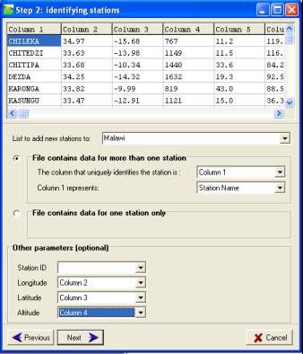
The following screen appears which requires that you give direction to AMS in terms of the contents of the columns. Indicate to which list the data should be added (Note: The list should created before importing the data). Indicate the column that uniquely identifies the stations and what column 1 represents by using the pull down arrow.

On other parameters, skip station ID as the data is being identified by station name. Indicate the columns that contain longitude, latitude and altitude.

If you are not sure of the columns contents, click on so that you could see the data and be reminded on which column contains longitude or latitude data.

When this is complete, then click .

AMS then checks the file line by line for valid station names. Some stations have been found in the database except a few and you just have to proceed and click
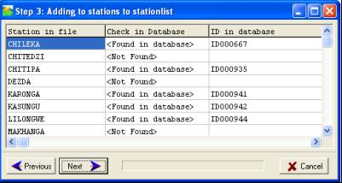

The following screen enables you to change the station-list. However, this is only necessary in cases where new stations were added and in this case its not necessary and so click No
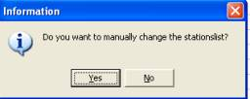

Then, you obtain the following which may be referred to as the data definition screen in which you specify exactly what the columns in the file represent. It is much easier for columns with single parameter like rainfall, evapotranspiration etc. However, when importing a crop parameter file with multiple parameters such as water holding capacity, planting dekad, cycle length etc, care should be taken to make sure appropriate columns are identified correctly.
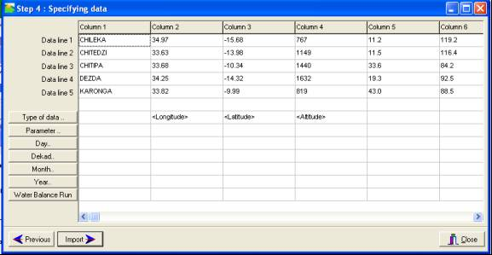

The longitude, latitude and altitude will be showing already and now you need to specify the type of data to import. You may place the cursor in the column (figure) or may use the column form to indicate the column (figure).
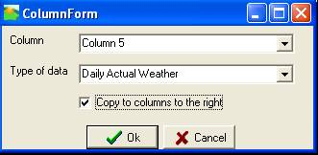
Click on type of data to define the type of data. The type of data being imported is “Dekadal Actual Weather” and the following columns contain the same type of data (therefore the “Copy to columns to the right” checkbox is checked). Click

Press the “Parameter” button and select “Rainfall” to specify the exact parameter being imported as shown in figure click to proceed to the next level.
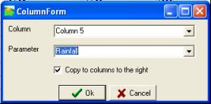

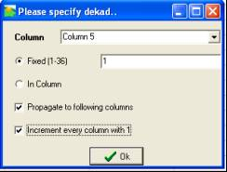
The data are dekadal, so you ignore the “Day” button. You press the Dekad button. The first column represents the first dekad of January. This is dekad number 1 in the year. Every next column represents the next dekad in the year. Click to proceed to the next level.

You ignore the “Month” button because the data you are importing is on a dekadal basis and not monthly.

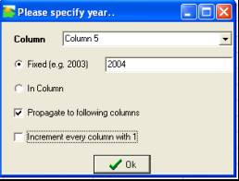
You specify the year depending on which year you are importing but in this example we are importing “2004” for column 1 to 36. The year will have to be propagated to all the following columns by checking the propagate box. Click to proceed to the next level.

You ignore the Water Balance button. Press and the importing process begins and the data are imported! In case of missing data you get the following message:

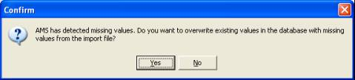

Answer “No” to prevent existing values from being overwritten by missing values. Press next and the data are being imported:

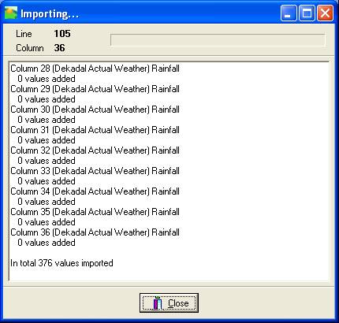

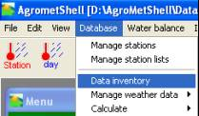
It is important to check if all the weather data are imported and in the database by checking the “Database ⇒ Data Inventory ” function.

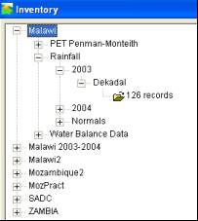

Importing the crop parameter file

The crop parameter file is the file that contains data for running the water balance calculation. It contains the water holding capacity, effective rainfall, the planting dekad, the cycle length, pre-season crop coefficient and irrigation data if needed.

The process of importing data starts in the same way as demonstrated for the rainfall data above. Once you obtain the screen to start specifying the data, then it gets slightly different as you have to specify each column as follows:

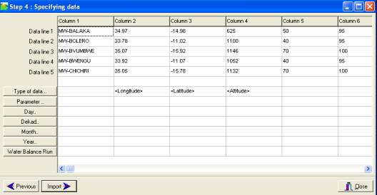

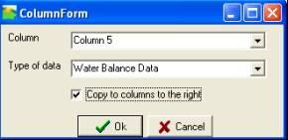
As in the previous exercise, you start specifying the type of data that you are importing. In this case, all the data being imported will be used in the water balance and so it is important that the data type is copied to the columns to the right.

The next stage is to indicate the “parameter” and clicking on parameter will bring up a screen that you need to indicate the type of parameter. This will have to be done for all the parameters as shown below:
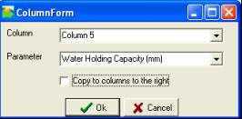
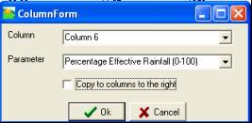

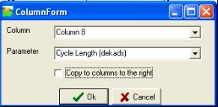
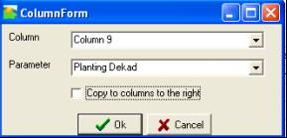

Section 5

Manual data entry into AMS

AMS can store daily, dekadal and monthly values. All values are stored independently in the database. As expected, monthly data can be calculated from dekadal and dekadal data can be calculated from daily values. Also, dekadal estimates can be created from monthly values. Entering of dekadal weather data manually is recommended when updating weather data on a dekadal basis once the dekad has come to an end. Once the data has been entered, a water balance model can be run.

Entering dekadal rainfall data

Start the “Database ⇒ Manage weather Data Dekad” function as shown in figure. Specify the list for which you want to enter then data, the parameter and the year:
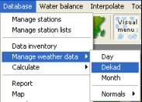

Select the station list which will contain the data and this case it is Malawi and then select the parameter, Rainfall and the year 2004.
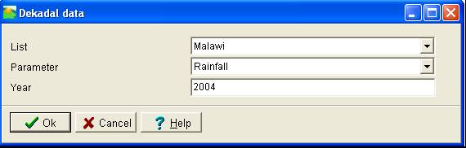

Click . The following screen is presented. In this screen you can enter new data. Simply move to the right cell in the input screen and start typing. AMS uses the dot as decimal separator. In this window two types of data can be entered. The top window provides access to actual data, the bottom window provides access to normal data.

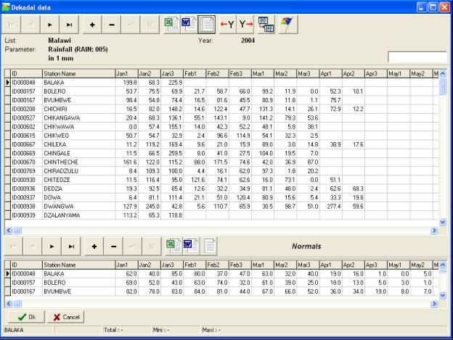

The two button-bars give full navigational functionality:

Button | Meaning
 | Move to first line
 | Move to previous line
 | Move to next line
 | Move to last line
 | Add a record for a station
 | Delete a record
 | Save the changes when editing a record
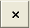 | Cancel the changes when editing a record

?[1] If there are no actual data available (in which case "actual" and "normal" are identical), then the "last" index is coded as missing.

