Section 6

Calculating monthly rainfall data from dekadal rainfall

Situations may arise that require that monthly values be calculated from the either the daily or dekadal data already in the AMS database. For this purpose, monthly values may be calculated as follows using the “Database ⇒ Calculate ⇒ Aggregate” function:
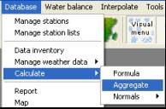

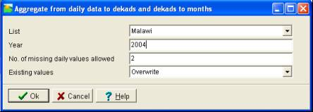

Press . Check whether the data have been calculated with the “Database-Inventory” function.
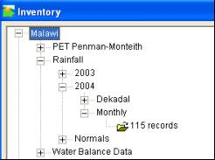

Section 7

The water balance

In early warning for food security you need an understanding of the condition of crops. Crops are dependent on water, and water is scarce in many developing countries. Especially in semi-arid countries water is the most important factor determining crop yield.

FAO has developed a simple method based on a water balance calculation scheme that will help you determine whether the agricultural season has performed well and that crops have had enough water to achieve a potential yield. The outcome of a water balance calculation is an index that roughly represents the percentage of needed water the plant has received during its cycle. In semi-arid areas this index is closely related to yield, presuming no other limiting factor is in place (such as crop diseases). In the new revised water balance model, other predictors besides the index can now be used to estimate yields of crops.

Besides the index many other useful parameters are calculated from the water balance. Very informative are:
- Actual evapotranspiration. In a number of cases yield is more closely related to actual evapotranspiration than to the WSI index.
- Water storage in the soil
- Water excess and
- Water deficit at various phenological stages

This manual will not provide details concerning the background of the water balance calculation. You can find a manual on the FAO Website. The water balance model is usually run on a dekadal (10-day) basis, although running it on a daily basis is possible. This will also be the time-step mostly used in this manual.

Calculating the water balance with AMS is a station based activity. Afterwards, the outcome of the calculations can easily be converted into images and aggregated by province/district to compare to yield data.

Data availability check

For the calculation of the water balance you need the following information:

- Dekadal Actual Rainfall
- Dekadal Normal Rainfall
- Dekadal actual PET. PET can be calculated from temperature, windspeed, humidity and other parameters that are only available from full-blown weather stations. Often actual PET data are not available. In that case normal PET data can be used with little damage to the accuracy of the water balance method.
- Dekadal normal PET.
- Crops. Which crops are grown? Each crop has its own crop coefficients.
- Planting dekads. In which dekad planting occurred?
- Cycle length of the crops grown.
- Water Holding Capacity of the soil.
- Percentage Effective Rainfall. This parameter is non-essential and is usually kept at 100%
- Pre-season crop coefficient. This is the “crop” coefficient related to bare soil.
- Irrigation amounts. This setting is very important for areas were there is a a lot of irrigated crops such as in Afghanistan where as much as half of the crops are irrigated.

Preparing a water balance

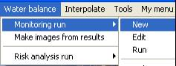
After checking the availability of data you can prepare a water balance. Activate the “Water Balance – Monitoring Run – New” function.

The following window is shown:
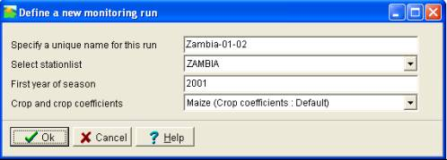

You specify a new name for the run. You choose for example “Zambia-01-02” for the 2001-2002 growing season. You will use the rainfall monitoring network in Zambia as a basis for the weather data. The selected crop is Maize. This crop is cultivated in almost all districts of the country as it is the main staple food crop in Zambia and many other African countries. In the following screen you can enter all the data needed for the water balance. The rainfall and PET are entered elsewhere (see previous sections).

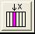
When setting a monitoring run for the first time, the screen may come empty. You may type in the various data requirements i.e. planting dekad, cycle length , water holding capacity , effective rainfall and pre-season crop coefficient. If the data sets to go into a column are similar, for example pre-season crop coefficient, there is a simpler way of inputting the data. Put the cursor in the column and press the following button:

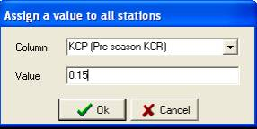
You will assign the value of 0.15 to the planting dekad. This means that you will the value to all the stations in the station list.

Press Ok. The pre-season crop coefficient column is filled with the value 0.15.

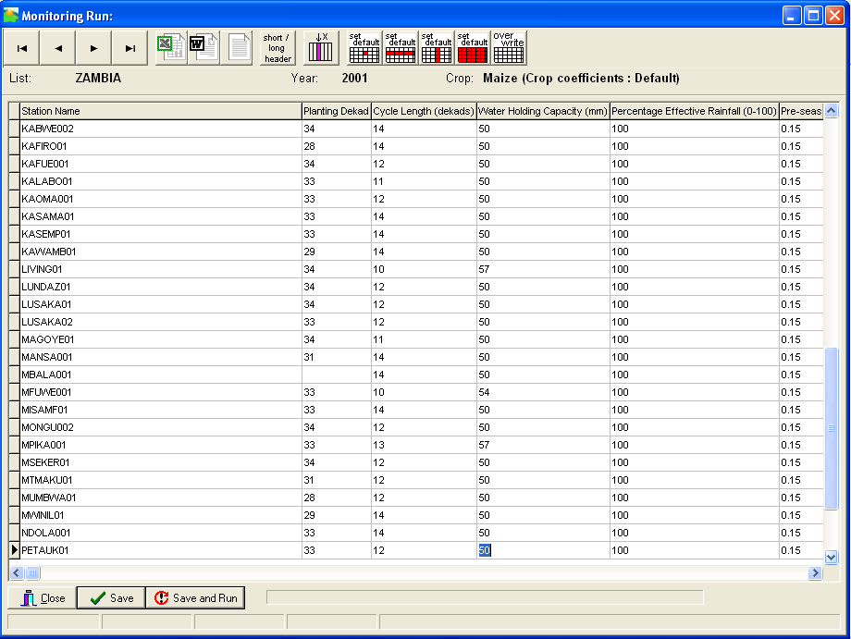

Do the same for the following columns. You assign the following values to the next columns where necessary :
- Cycle length : 12 dekads
- Water Holding Capacity of the soil : 50 mm
- Percentage effective rainfall : 100 %
- Pre-season Kcr : 0.15
- Irrigation application : 0 (this means NO irrigation)
- Irrigation bund height : 0

Refining the water Balance

You have just completed a very simple Water Balance calculation. You have assigned the same values to the water balance parameters for all stations. In this paragraph you will discuss the possibilities to make the water balance calculation more realistic.

Filling Data gaps

First of all you have to try to fill gaps in the data. In the previous chapter you have seen that you do not have enough ground data for Zambia. In the following order you should try to do the following:
- Try again to get the data from the station and enter them in AMS. Measured values are always best.
- If you lack rainfall or PET data, extract the data from the 10-day data provided by ISPRA. Rainfall is in column J. PET is in column K.

Col | Parameter Description | Param | Unit
J | Precipitation (Rainfall cumulated for the 10 days period) | rain10 | mm
K | Potential Evapo-Transpiration (cumulated for the 10 days period) | pet10 | Mm

Please note that these data should always be second choice! Therefore never overwrite ground data. Furthermore, mark the data with “E” for “estimate”. Should ground data come in at a later stage, replace the satellite data with ground data in AMS.
- If you cannot achieve any of the above solutions, you can use the function “Tools – Interpolate for missing data” to interpolate for missing data.
- Another method is by creating an image using one of the interpolation techniques (see “Interpolation” menu) and extracting values from this image into the database (function “Database – Import – From image”). This has previously been described.

Calculate planting dates

Measured values are always the best data around. So if you have planting dates for Afghanistan you should enter them. However a good approximation of planting dates can be figured out with rainfall records. Planting usually occurs as a result of rainfall exceeding a certain amount. You can let AMS calculate the planting dates for us, based on this simple algorithm. Activate the “Water Balance – Monitoring Run – Calculate planting dekads – Based on Rainfall Threshold” function. You will assume that planting occurs when 20 millimeters of rainfall have been exceeded.

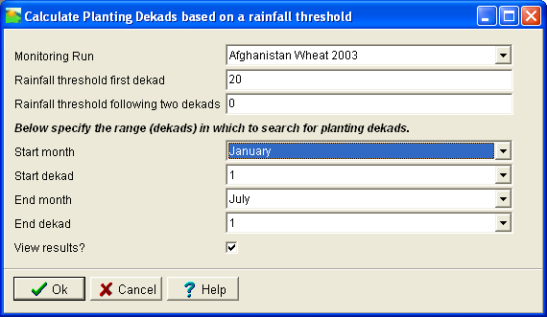

Press OK. Notice that the planting dekads can changed from 1 into other dekads. Whenever the 20 mm rainfall threshold between January 1 and July 31 is not exceeded, the planting date is made “missing value”

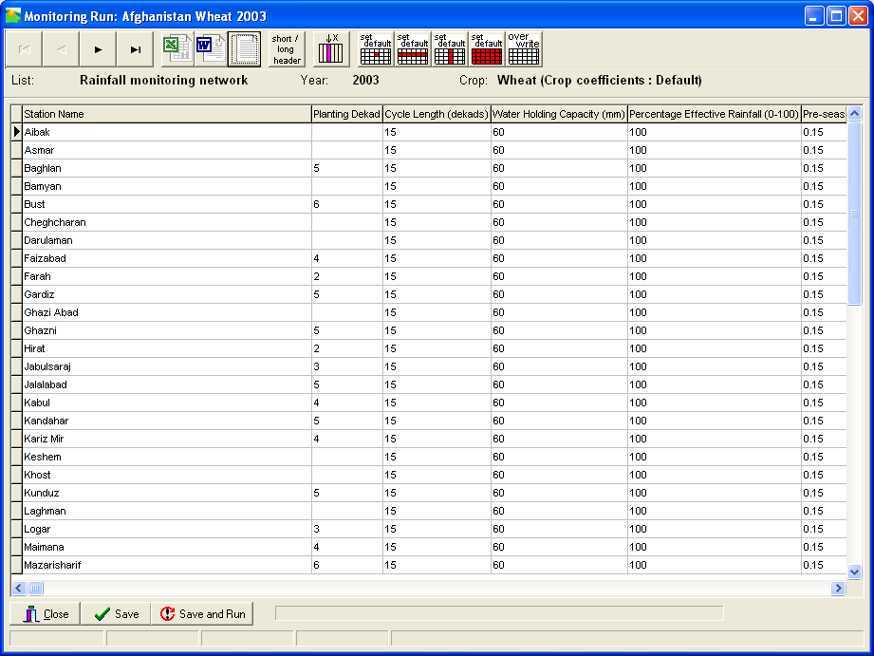

“Save and Run” the Water balance to see the results.

Adding Irrigation

In Afghanistan, irrigation is applied to roughly 50 % of the cropped area. In many places a crop would never reach maturity without irrigation. AMS gives the user the possibility to add irrigation to a crop at a certain station. AMS provides two methods of irrigation:

Automatic irrigation

This type of irrigation will ensure that the crop will never experience water stress. Therefore the final index will always be 100. This type of calculation is useful as it calculates the actual evapotranspiration without water stress. This parameter is closely related to crop yield. Furthermore it also tells you how much water the crop uses to mature. On this knowledge irrigation amounts can be based. Automatic irrigation can be switched on by entering a “2” in the “Irrigation Application” field of the Water Balance.

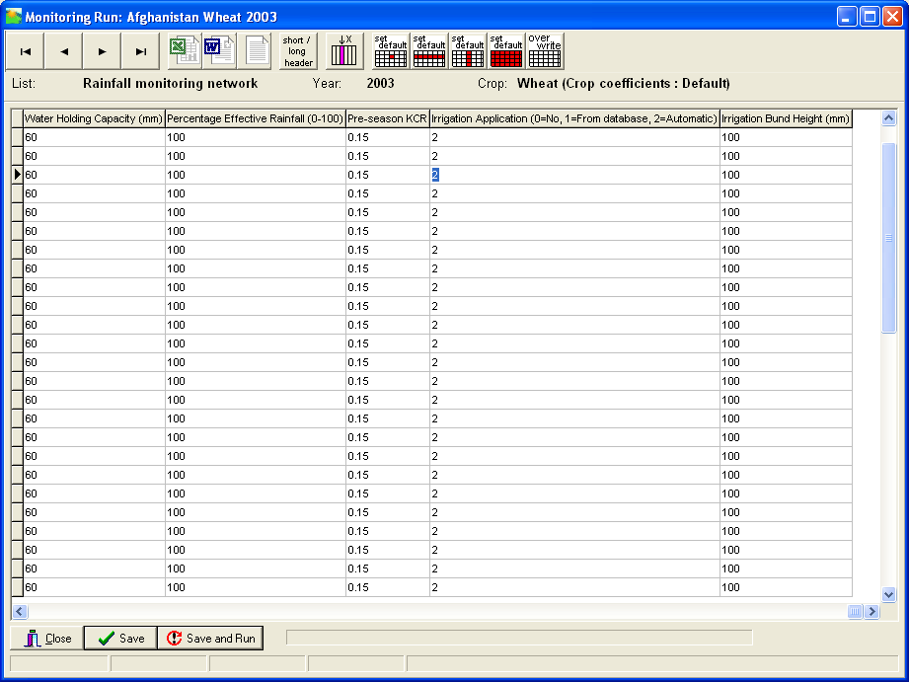

“Save and Run” the water balance to see the result. Yellow bars in the graph indicate the application of automatic irrigation.

Running the Water balance

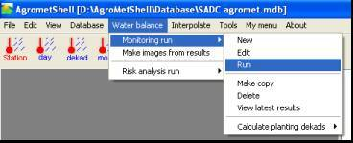
Running the water balance model

Select the water balance run as shown in figure.

Use the pull down menu to select the appropriate run file in the Monitoring Run

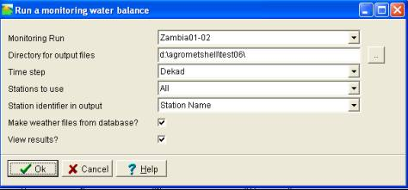
Fill the resulting screen as follows:

You can either select all the stations in the database or select stations for your country in Stations to use. Then click

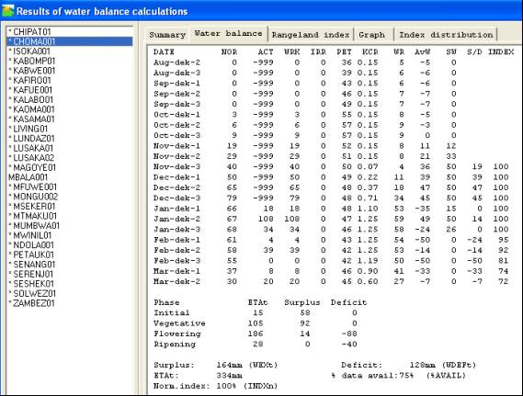

The left side of the screen gives the name of the stations. The stations Choma is selected. For this station, the calculations could not be finished, due to lack of weather data. Stations for which a water balance is successfully calculated have a “*” in front of the name.

A water balance has been calculated. The blue bars indicate actual rainfall during the dekad (10-day period) while the green bars indicate the water requirement of the crop during each dekad. Look at the graphs and identify dekads where the rainfall was loyour than what the crop needed at that particular dekad. This could have created some stress in the crop. You can view the water balance by clicking on water balance to see the actual calculations.

The red line indicates the water requirement satisfaction index which is the extent to which the water requirement has been satisfied. No irrigation is applied.

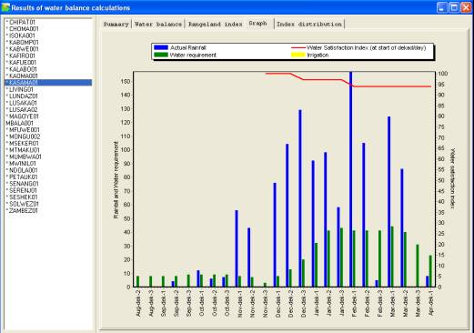

Inspect the water balance graph for Chipata:

Manual irrigation

In this case the irrigation is applied manually for each station. In AMS irrigation is considered a meteorological parameter that can be entered using the weather parameter input screens.

Enter dekadal irrigation amounts in the following way:
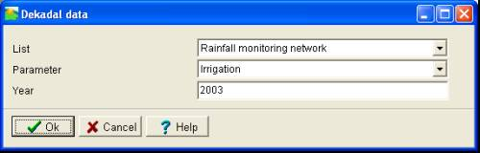
Go to the option : “Database – Manage Weather Data - Dekad”. Specify for example the following settings:

Press Ok. Enter the irrigation amounts in the same way as you would enter rainfall.
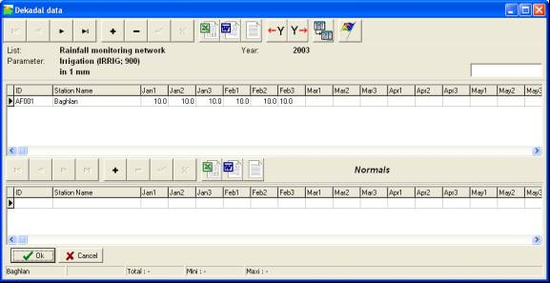

Press OK, Activate the “Water Balance – Monitoring Run - Edit” option and change the “Irrigation Application” field of the Water Balance sheet to 1. By pressing “Save and Run” you calculate the water balance with these amounts of irrigation. The viewer will show the following results:

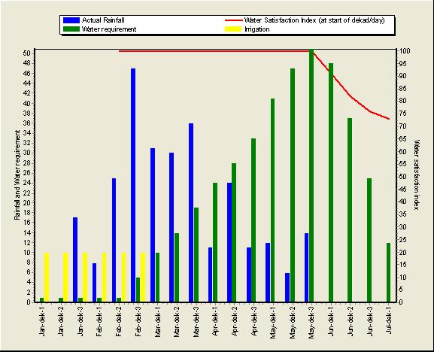

Removing and adding stations from the stations list

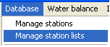
Stations can be removed or added to the stations manager in the AMS software. To remove or add a station, you invoke Database ⇒ Manage station lists as shown.

The following screen appears which allows you to load an existing stations list from you which you are going to remove or add stations.
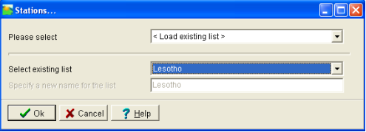

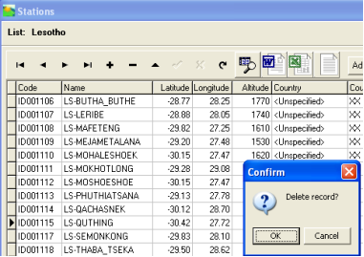

Once you click OK on the screen for loading the station list, you obtain the following screen from which you can remove or add a record using the menu above (in read) as shown in the diagram.

Add record

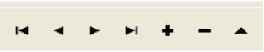
Remove record

Section 8

Making images from the water balance calculation

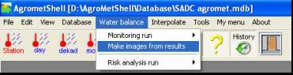
Select water balance and then make images from results

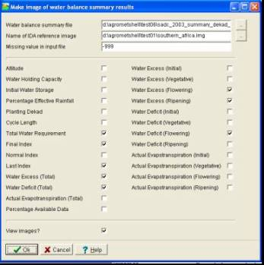

Make sure the appropriate summary file is selected in the water balance summary file. Select the images that you want to make by checking the boxes.

The images will show you which areas had excess water at different stages of the crop in cases where there was a lot of rainfall, areas where there was water deficits at different stages of the crop due to low rainfall.

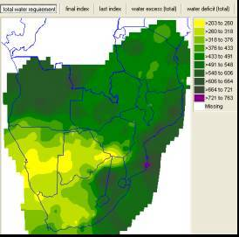

The figure shows an image of the total water requirement. Click on the various images to view the other images selected.

Making a risk analysis for a station

Risk analysis will provide you with information on how many times the water requirement has been higher than a certain level in the time period under study. Select water balance then risk analysis run and then new.

(Rainfall data in the database is from 1981-2004).
From NEW, provide a name of a station of your choice (e.g. Maputo 1981-2003) then select a station from the pull down menu as shown in the figure. Indicate the time period for the analysis from 1981 to 2003. Click

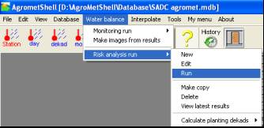
Look at the index distribution frequency graph with wrsi on the x-axis and number of years on the y-axis.

How many years had a wrsi of 50 and below?

How many years had a wrsi of 65 and below?

How many years had a wrsi of 75 and below?
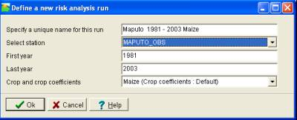
How many years had a wrsi of 85 and below?

What does this analysis tell you about this station? This analysis was done for a maize crop, would recommend that communities continue to grow the crop?

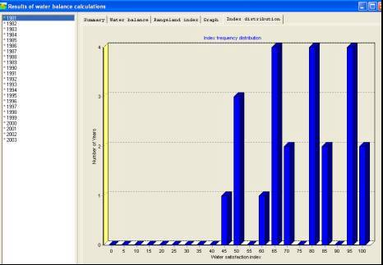

Section 9

Displaying data in simple way

It is always good to display your data for visual assessment. You can display data in several ways. These display functions are added for quick reference and easy analysis of the data.

Mapping data in AMS

To explore the mapping possibilities of AMS. Activate the pull down menu and start the “Database-Map” function. In the screen, “creating a map from Database data, fill in all the required information as shown in the figure.
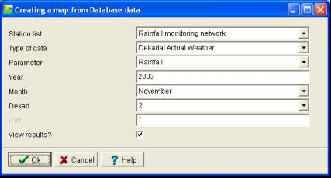

Click and a map will be displayed:

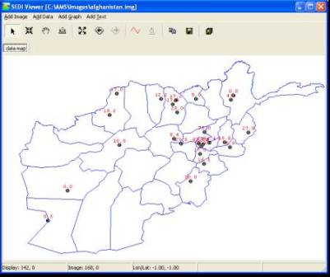

The toolbar provides the following functionality:

Button | Meaning
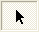 | Cursor
 | Zoom in
 | Pan
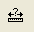 | Measure distance between two points
 | Zoom out
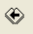 | Previous view
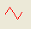 | Load another boundary file
 | Copy to clipboard (e.g. to copy image to Word)
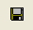 | Save image a bitmap
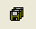 | Save the set of displayed files

Mapping data in WinDisp

You will map the same data in Windisp. Windisp enables you to improve the lay-out. When inserting a map into a bulletin, Windisp is the preferred application to prepare your images for presentations.

First export the data to BNA format using AMS. Use the “Interpolate – Make input file – Database” function. As an example take the following settings:

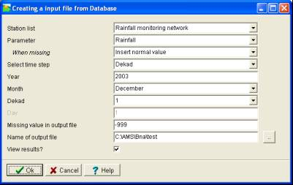

Be sure to tick the “View results?” option. Press Ok. In this example, the directory “c:\ams\bna” will contain two output files. The file with the extension “bna” is the one you need.

Perform the following steps:
- Open Windisp
- Use the function “File-Open-Map” to display a background map (e.g. afgad1.bna).
- Use the function “Draw-Labels” with the “bna”-file you just created.

You should now see a map of Afghanistan with superimposed the rainfall data.
- Annotation can be added. E.g. Rainfall dekad 1 December 2003 using the “Draw text” function.
- You can copy your work to the clipboard with the Edit-Copy function. In Windisp Draw a window that covers the part of the screen you want to copy.
- Paste the map into any Word document with CTRL-V.
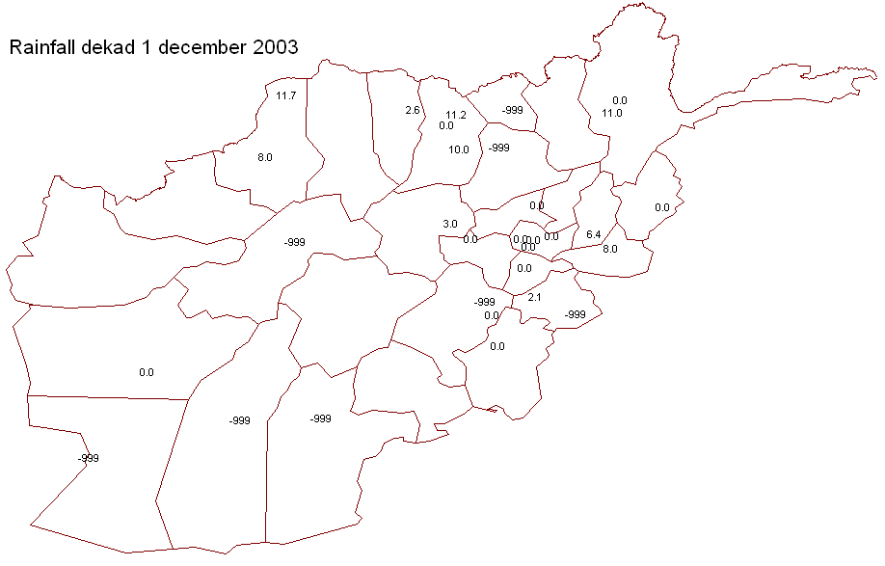

Section 10

Interpolation of data using AMS

Visual assessment of bigger picture will always relay more information that looking at one locality in this case a station. In Agrometeorology or in food security, you are not only interested in what happens at the station level, you want an estimate of what happens in between so that you can get a complete and bigger picture. In order to do this, you have to convert our data from the world of tables to the world of images.

Using the inverse distance interpolation method

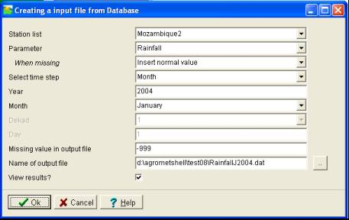
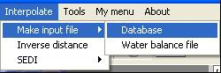
To perform an interpolation, first export the data to CSV format using AMS. Use the pull down menu as shown in the example “Interpolate – Make input file – Database” function.

Provide the necessary inputs in terms station-list, parameter, year and month, missing value in output file and output file. Then click

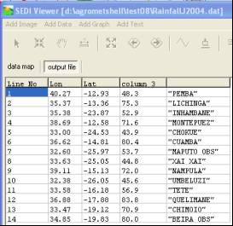

The output file created will shown as in the figure with station names, longitude, latitude and rainfall. The data is now ready for interpolation using AMS. Interpolation may be necessary when you some times intend to make images after running a water balance and images do not appear. The reason that there are not sufficient stations to create an image and so may have to create the data as done and increase the interpolation distance.

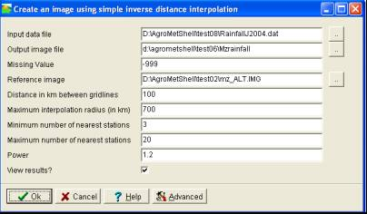
After creating the input file as shown above, the interpolation process can now begin using the created input file as shown.

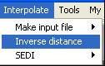

Then click

The following image will be the result:
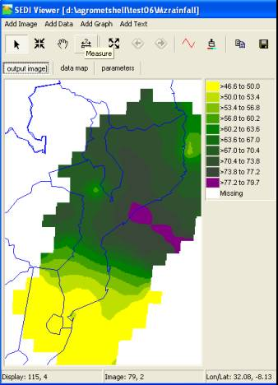

Such images may be useful for inclusion in the Agrometeorological Bulletins and therefore you might use the copy to clipboard functionality ( ) at this stage to paste the map to Microsoft Word.
Try to re-do the previous exercise with different settings under Distance in Km between gridlines, Maximum interpolation radius (in Km), Minimum number of nearest stations and Maximum number of nearest stations. Notice the difference in the resulting images. Exercising with the settings is the best way to understand them.

