REGIONAL FOOD SECURITY PROGRAMME
GROWING SEASON STATUS
Rainfall, Vegetation and Crop Monitoring

2001/2002 Issue 6 March 2002

Release date: 30 April 2002

Highlights

- The prolonged dry spell develops into a drought affecting Botswana, Swaziland, southern Mozambique, southern Zambia, most of Zimbabwe and Malawi ...

- The food security prospects at both national and regional level uncertain as drought sets in. FAO/WFP Crop and Food Supply Assessments to take place in drought affected countries …

- The 2001/2002 rainy season was performing well in northern parts of the SADC region …

- Analysis of Meteosat satellite imagery shows the ITCZ continuing to oscillate in the northern half of the SADC region …

- 2001/2002 drought in Zimbabwe intensifies …

Contents

Editorial… Pg. 2

WRSI indicates Dry
Areas … Pg. 2

Season Development… Pg. 3

Time Series and Country
Profiles… Pg. 3

CCD images… Pg. 4

NDVI images… Pg. 5

Time Series and Country
Profiles Continued… Pg. 6

Situation Map… Pg. 8

SADC Member States: Angola, Botswana, Democratic Republic of Congo, Lesotho, Malawi, Mauritius, Mozambique, Namibia, Seychelles, South Africa, Swaziland, Tanzania, Zambia, Zimbabwe

Published by: SADC Regional Remote Sensing Unit

P.O. Box 4046, Harare - Zimbabwe
Tel: +263-4-736051/2
Fax: +263-4-795345 or 795283
Email: rrsu@fanr-sadc.co.zw
Website: www.sadc-fanr.org.zw

EDITORIAL

The Regional Remote Sensing Unit (RRSU) is pleased to present the sixth issue of the Growing Season Status Report for the 2001/2002 rainy season, covering all the dekads (10-day periods) in the month of March 2002 .

The analysis presented in this bulletin is based on Meteosat derived Cold Cloud Duration images, which are received through the RRSU managed PDUS receiving station located at the Zimbabwe Meteorological Department in Harare, Zimbabwe; and NOAA-derived NDVI and RFE data which are processed by NASA and obtained through United States Geological Survey (USGS) in South Dakota.

The RRSU is providing regular updates on the progress of the 2001/2002 rainy season through the Agromet Update, distributed by the SADC Regional Early Warning Unit and posted on the FANR web-site (www.sadc-fanr.org.zw). A situational Regional Flood Watch publication is also produced in collaboration with FEWSNet and posted on the same web site.

This bulletin does not include the SARCOF seasonal forecast updates. Please note, however, that these forecasts are presented on the FANR Web-site and regular publications of the Harare-based Drought Monitoring Centre (DMC) that are available at their web site (www.dmc.co.zw).

The start of the season was characterised by widespread rains across the northern, central and south-eastern parts of the SADC region in the third dekad of October. In November most parts of the region received rain except for coastal Angola, most parts of Namibia, parts of western South Africa, most of Tanzania, northern Mozambique, northern Malawi and the extreme north-eastern parts of Zambia and Zimbabwe. The 2001/02 season progressed well up to the second dekad of December when the dry spell started. The prolonged dry spell persisted into February and March, resulting in the current drought situation.

Analysis in this bulletin is primarily an interpretation of satellite imagery, with incorporation of appropriate ground information. Ground data and interpretation are provided by collaborating national meteorological services and national early warning units of the SADC Member States and are summarised in the situation map on the last page.

The focus of this bulletin is primarily at regional level. At the moment the RRSU satellite image archive does not include the Democratic Republic of Congo, the Seychelles and Mauritius. These countries will be included in future bulletins. However, any information available has been included in this report. For more detailed sub-national analysis, readers should consult national meteorological agencies and food security early warning units.

ACKNOWLEDGEMENT
The RRSU acknowledges financial support from member states (through the REWU) and from the EC through an EC-funded FAO project. FAO provides technical support

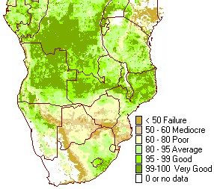

Figure 1. Brown shading indicates areas with crop failure

Regional Crop Water Satisfaction Index (WRSI)

Drought conditions prevailed across the central parts of the region since the beginning of the year with much of Zimbabwe, eastern Botswana, southern Zambia, extreme northeastern South Africa, central and southern Mozambique receiving little or no rainfall at all. High temperatures compounded the effects of the dry conditions, stressing crops and culminated in total crop failure in most areas.

The Water Requirement Satisfaction Index (WRSI) provides a measure of the extent to which the crop water requirements have been satisfied. WRSI for the last dekad of March (figure 1) indicated that crops in the northern half of the region were performing well as there was sufficient moisture to support crop development. The image also indicated areas that had severe water deficits (brown shading) since the beginning of the growing season. Thus it reflected areas that had significant water deficits as rainfall was not favourable in the central and southern parts of the region, with a severe reduction in crop yields. Ground reports indicated that large areas were affected by drought with maize fields being affected extensively. The drought affected areas included southern Mozambique (parts of Maputo, Gaza and Inhambane provinces, Sofala, Tete and central Zambezia), almost entire Zimbabwe, Botswana, Swaziland, northern parts of South Africa, Malawi and Zambia. The affected areas will be targeted by the planned FAO/WFP/SADC Crop and Food Supply Assessment missions to be fielded in April and May 2002.

DISCUSSION OF THE SEASON DEVELOPMENT

Spatial Aspects

Meteosat – Cold Cloud Duration Information

Refer to Figure 2 on page 4 for the CCD images.

Significant rainfall activity was observed across much of the region during the first dekad of March; the only exceptions being northern South Africa, northern-eastern Botswana, eastern and southern half of Zimbabwe, central and southern Mozambique where the dry conditions persisted. With the easing of suppressive air circulation patterns over Zimbabwe, frontal clouds in the south of the sub-region linked up favourably with the heavy cloud activity in southwestern Angola and northwestern Namibia to give significant rainfall to the previously dry areas of southeastern Namibia, most of Botswana, western Zambia, northern and northwestern Zimbabwe and central Mozambique in the first dekad. These rains benefited those crops that had not been damaged by the prolonged dry spells and drought, especially in South Africa, Lesotho and Swaziland.

Rainfall activity in the second and third dekads of March shifted to the northern half of the region, which enjoyed favourable rainfall as indicated by intense cloud activity across the DRC, Angola, Tanzania and Malawi, together with northern Zambia and northern Mozambique. The high rainfall activity across Tanzania also indicated the favourable start and progression of the main rainfall season. The southern half of the region was relatively dry, marking the end of the rainy season in these areas.

NOAA – NDVI Information

Normalized Difference Vegetation Index (NDVI) images (presented in Figure 3 page 5) showed that throughout the month, vegetation development in southern Zambia, most of Zimbabwe, northern Botswana decreased. However, by the third dekad of March, there was significant improvement in the vegetation condition in most of the bimodal rainfall areas of Tanzania, northern DRC, coastal Angola and parts of central South Africa. In general, vegetation development was on the increase in Lesotho, central South Africa, northern Zambia, Malawi, northern Mozambique, most of the DRC and northern Tanzania.

Comparison with the average images showed that vegetation status was below average in southern Zambia, parts of north-western and southern Zimbabwe, north-eastern Botswana and parts of southern Mozambique. This was in response to the poor rainfall performance that had been witnessed in these areas. Parts of the north-eastern Democratic Republic of Congo and northern Tanzania showed improvements in vegetation status in the month of March but it is difficult to judge the full extent of this vegetation development due to the persistence of cloud cover for most of the month.

Central South Africa and Lesotho showed above average vegetation development by the last dekad of March. Most of the region had average vegetation conditions.

Time series and country updates

One of the RRSU products derived from satellite information are data extracts from CCD imagery, which are presented as cumulative values compared with a 13-year (1988-2001) average for specified sub-regions of SADC. These sub-regions can be administrative boundaries, watersheds, or agricultural areas. Suggestions for new areas to allow a more focussed monitoring are welcome. A number of CCD curves are here presented with an update for the SADC countries for which satellite and/or field information is available.

Continued on … page 6

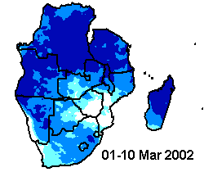 | 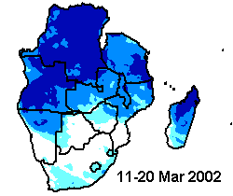 |  | 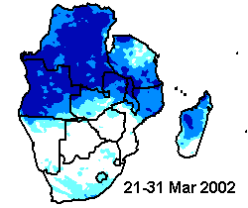
Upper Row: CCD March 2002 |  | low high
Lower Row: CCD Difference from Average |  | worse better
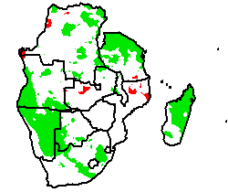 | 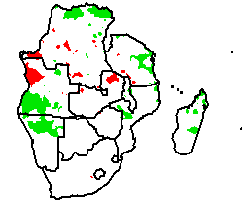 |  | 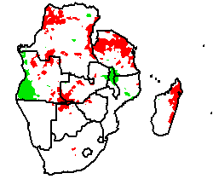

Figure 2. Cold Cloud Duration (CCD) images, March 2002 and difference from average
From left to right are dekads 1 (1-10), 2 (11-20) and 3 (21-31)
Differences from average, lower row, are based on a long term average of 1988-2001

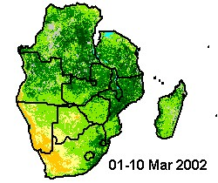 | 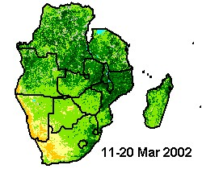 |  | 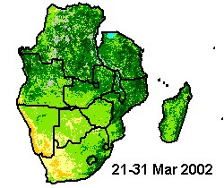
Upper Row: NDVI March 2002 |  | 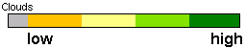
Lower Row: NDVI Difference from Average |  | worse better
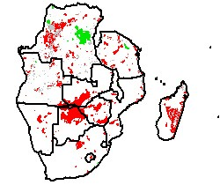 | 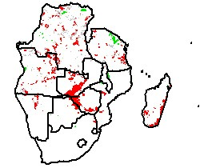 |  | 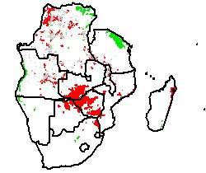

Figure 3. Normalized Difference Vegetation Index (NDVI) images, March 2002 and difference from average
From left to right are Dekads 1 (1-10), 2 (11-20) and 3 (21-31)
Differences from average, lower row, are based on a long term average of 1982-2001
Continued from page 3

The agricultural and climatic situation in each of the SADC member states can be summarised as follows:
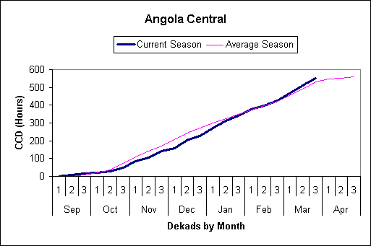
Angola:
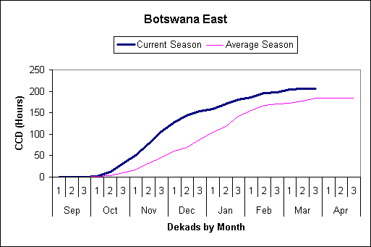
The Cold Cloud Duration images indicated that most of the country received high amounts of rainfall. The coastal areas which had been dry in previous dekads consistently received high amounts of rainfall for the whole month. It was anticipated that crops were at their advanced stage of development and probably maturing and being harvested where early planting took place. A good harvest was being expected.

Botswana
The country continued to experience dry conditions in most parts diminishing all hopes of recovery in the staple food crops. No significant rainfall was recorded during the period under review. This has continued to have devastating effects on crop performance, with crops reported to have virtually wilted due to drought in many areas of the country. The pastures and livestock were also experiencing unfavourable conditions as pastures were not very palatable due to drought. The dry spell resulted in total crop failure, however drought resistant crops might help salvage the situation by providing yield. Beans and watermelons were being harvested.

Democratic Republic of Congo
The Cold Cloud Duration image indicated high rainfall across the country. The DRC had consistently received very high rainfall during the growing season. Most crops had reached maturity and high rainfall could have had serious implications on the drying of the cobs as it could result in reduced yield due to cob rot.
Lesotho
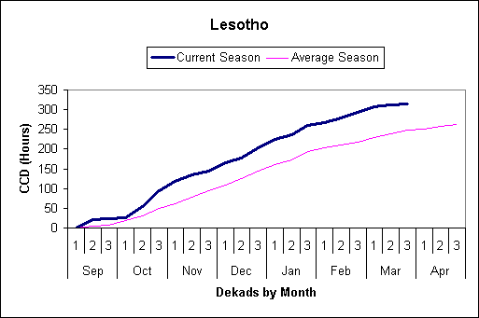
Relatively high rainfall was registered over the central region of the country, while fairly low rainfall was received elsewhere. The entire country recorded far below normal rainfall for the month. However cumulative rainfall for all stations indicated normal to above normal rainfall. This implied that there was adequate soil moisture to keep crops surviving. Late planted maize crops over the highlands experienced extremely low temperatures which had negative impact on the crop still at grain-filling stages, and might result in reduced yield. In general maize and sorghum crops are at grain-filling to maturity stages while some crops over the Highlands were at early maturity stage and in fair to good condition. Summer wheat harvesting was in progress.
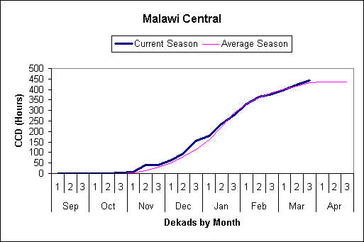
Malawi
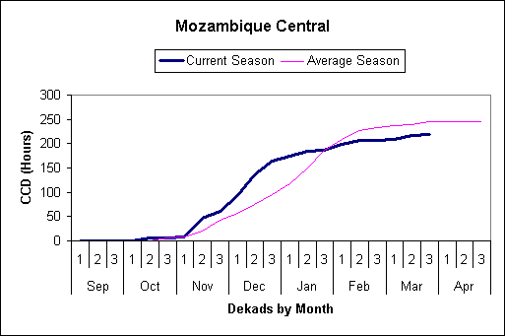
During the month, rainfall declined in most parts of the country, especially in the southern and central regions where all districts experienced a dry spell for almost three weeks. Some crops wilted and those at tasselling and cob- formation stages were badly affected. The declining rainfall activity was attributed to the northwards withdrawal of the ITCZ. In major maize producing areas of the central region, the three to four weeks dry spell severely impacted on maize at tasselling and cobbing stages. The season was generally progressing well in the northern region. Despite the dry spells, most areas received normal to above normal cumulative rainfall for the season. There were reports on premature harvesting of green maize for consumption and sale due to current tight household food security situation.

Mozambique
The northern half of Mozambique experienced substantial amounts of rainfall while the south continued to be dry. Dry conditions in the south have prevailed since January and reports indicated that over 100 000 hectares of cropland with maize had been affected extensively. The drought stricken areas include parts of Maputo, Gaza and Inhambane provinces, in the south, and Sofala, Tete and Zambezia in the centre. Crops in the northern areas were in good condition and a better harvest was being anticipated. The CCD curve for central Mozambique indicated below normal cumulative rainfall for the period under review.
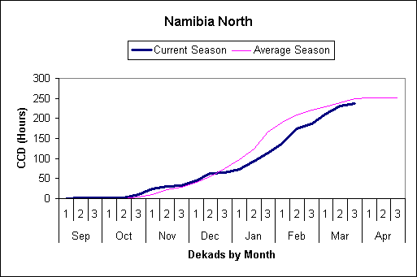
Namibia
Moderate rainfall was received during the first dekad of March in most parts of the country. The Cold Cloud Duration images (figure 2) indicated that the Kavango and Caprivi, which are the main agricultural areas, received good rains while the coastal areas continued to be dry. For the rest of the month, low rainfall was received in most parts of the country. Crop assessments conducted indicated that the dry conditions experienced could adversely affect the crop yields. Pastures and livestock condition ranged from poor to good.

Seychelles
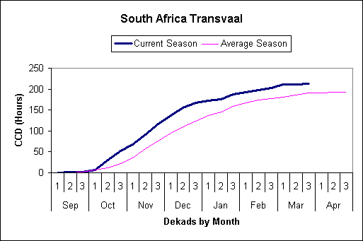
During the beginning of the month, the weather was mostly dominated by tropical cyclone ‘HARY’ which brought ample rainfall to the Seychelles Islands. As it progressed westward, the cyclone passed to the immediate south of Agaléga, and the vortex of the cyclonic system brought strong winds, heavy rain, thunderstorms and lightning affecting Faquhar, Coétivy and the Amirantes Islands. Mahé and the Inner Islands registered a maximum rainfall of 163.4mm at Fairview and Rochon and minimum of 43.5mm over Praslin. Most of the stations on the inner islands received below 100mm. Extreme dry conditions were observed over most of La Digue, Praslin, Curieuse and Félicité islands. However, Mahé and the Inner Islands were relatively dry.

South Africa
Commercial maize yield estimates were reduced by 2.5 percent because of unfavourable weather in the previous month in most of the maize growing areas There was apprehension that if there is an early onset of frost, the late-planted maize crop yield might be further reduced. South African sunflower output was estimated at 782 940 tonnes, from 796 940 last month and 638 320 last year. Farmers indicated they would plant 938 900 hectares of wheat for the 2002/03 season. They planted 959 400 ha in the previous season to produce 2.493 million tonnes of wheat.
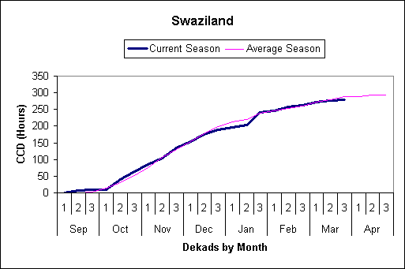
Swaziland
Low rainfall was received during the month of March. The moisture stress that the maize crop suffered earlier in the season, especially in the Lowveld and dry Middleveld, would definitely affect the yields. Late planted maize could be affected by dry conditions. The final maize production is expected to be much lower than average. Pasture and livestock were in good to fair condition.

Tanzania
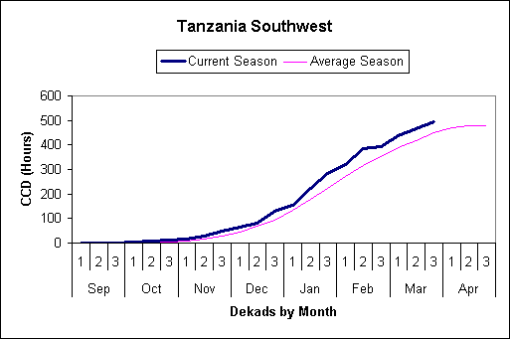
During the period, unimodal rainfall areas (central, western, southern and southwestern) continued to enjoy ample soil moisture supply. Crops such as maize and beans were in good state and in the late vegetative stage. In some places beans had matured. Perennials like bananas, coffee and cassava were flourishing given the adequate soil moisture. Over bimodal areas especially (northern coastal belt, northeastern areas), fast farm activities resulted in crops reaching early vegetative stage by the end of the month. Armyworms were reported to have destroyed about 16,000 hectares of crops (maize and beans) and pastures in some parts of Kilimanjaro region. Higher rainfall above 400mm was recorded in southern Morogoro and Kagera regions while relatively lower amounts around 100mm were observed over northeastern areas. The rest of the country registered between 100-200mm. Northeastern areas of the country recorded an early onset of masika which has contributed to rainfall amounts catching up to near normal levels towards the end of the period.
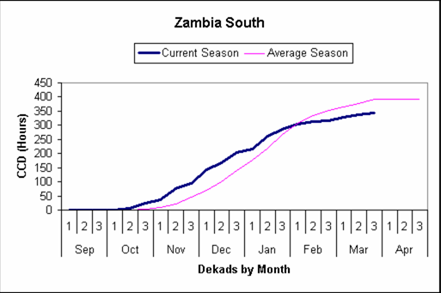
Zambia
Isolated heavy rainfall received over the extreme northern parts of the country during the third dekad while elsewhere no rainfall was received. The cumulative rainfall performance since the beginning of the season has been deteriorating by dekad over the southern half and significant deficits have been recorded as drought conditions spread northwards. No significant rainfall was being expected by the end of the month as the ITCZ was withdrawing northwards indicating the end of the rainy season for the southern parts. In these areas, the crop that has survived the long dry spells has matured and in some cases being harvested. Crops have done very well in the northern half of the country which experienced good rainfall during the growing period and are now at maturing stage. However, continued heavy rainfall may cause damage to the maturing crops.
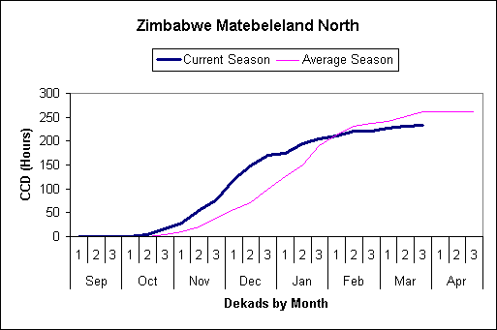
Zimbabwe
Light, widespread showers were received at the beginning of the month. In some districts, the early crop performed fairly well and was being harvested. Most of the crop established with the onset of rains from mid November to early December was written off due to the dry spell which started in December and January consecutively in different areas. Poor rainfall still continued as light widespread showers were received, adversely affecting crops. Crops assessments conducted by the NEWU indicated that most of the crops were affected by the drought with very little expected for harvesting. Southern Zimbabwe was the worst hit. Cumulative rainfall indicated that since January to date, the southern areas received little or no rain at all.

